GENERATIVE AI ENGINEERING WITH DATABRICKS

WEEK 1
Module 1 - From prompt engineering to RAG (DAY 1)
Prompt – to communicate with LLM
Instructions should be very clear
Good prompt –
- Clear system instructions
- Input/questions
- Output format – json
- Context – supportive info related to the question – It might be in some db, in some cloud, in some cloud db. It might be in a pdf document, it might be in an image, structured or unstructured format.
Zero Shot Prompting – Prompt that generates text or perform a task without providing any examples or additional training specific to that task.
Few shot prompting – Prompt provides with a few input/output examples to guide the model for generating the desired output.
Prompting chaining – Multiple tasks are linked together, with the output of one prompt serving as the input for the next.
Chain of thought prompting (COT) – COT Prompting enhances the reasoning capabilities of LLMs by guiding them to articulate their thought process step-by-step, which is similar to human reasoning.
- Prompts are model specific
- Iterative development is the key. Iterate by adjusting the temperature parameter. Higher for more creative outputs. Lower for focused responses.
- Beware of bias and hallucination.
FORMAT PROMPTS –
- Use delimiters to distinguish between instruction and context.
- Ask the model to return the structured output.
- Provide a correct example.
GUIDING THE MODEL –
- Ask the model not to make up things/ hallucinate.
- Ask the model not to assume/ probe for sensitive information.
- Ask the model not to rush to a solution. Ask it to take more time to think -COT Prompting
BENEFITS –
- Simple and efficient
- Predictable results
- Tailored outputs
LIMITATIONS –
- O/P depends on used models
- Limited by pre-trained model’s internal knowledge. For external knowledge, we need to use RAG.
HOW DO LANGUAGE MODELS LEARN KNOWLEDGE –
- Model Pre Training – Training an LLM From scratch. Requires large datasets
- Model Fine Tuning – Adapting pre trained model to specific datasets or domains
- Passing contextual information – Combining LLM with external knowledge retrieval. Required external knowledge base.
Passing Context to LLMs helps factual recall. LLMs are evolving to accept large/infinite input token window size.
Downsides of Longer context –
- Higher API Costs
- Longer completion times
- Content may be overlooked/ignored.
WHAT IS RAG ? –
RAG is done by retrieving data/documents relevant to a question or task and providing them as context to augment the prompts to an LLM to improve generation.
RAG – RAG solves the knowledge gap problem. We have a private db, our responses might not be very accurate as per our db details.
We need to create pipeline using Vector DB because LLM isn’t trained on my private db
Vector DB – Retrieve domain related context from this.
RAG Use cases –
- Q&A Chatbot
- Seach augmentation
- Content creation and summarization
MAIN CONCEPTS OF RAG WORKFLOW –
- Index & Embed – Embedding model used for creating vector representation of documents & user queries.
- Vector store – To store unstructured data indexed by vectors
- Retrieval – Search stored vectors using similarity search to efficiently retrieve relevant information.
- Filtering & Reranking – Process of selecting or ranking retrieved documents before passing as context. Filtering can be pre, post, ad-hoc.
- Prompt augmentation – Prompt engineering workflow to enhance context via injection of data retrieved from vector store.
- Generation – LLM used for generating a response for user’s context.
BENEFITS OF RAG –
- Up to date responses
- Less chance of inaccurate responses
- Domain specific contextualization
- Efficient and cost effective
RAG Architecture –
- Document embedding
Source of pdfs – unstructured data coming on ETL Pipelines stored in a folder in the datalake. Volume (Managed folder by unity).
Large documents go through chunking, Large document was broken into small small pieces.
Databricks is hosting some of the embeddings model. You can create more embedding models as well.
Embedding – Takes text as input, gives it a number as per the semantic meaning. It will give a vector array
Chunks will be sent to embedding model. If I send 3 chunks to embedding model, it will give 3 vector embedding. Each vector size is 1024.
Batch size = 150 = 150 chunks are going in parallel, and 150 embeddings will be created.
These vectors are sent to vector DB.
Vector db is called vector search in Databricks.
In vector search, we have a table called Index.
In Index, one column is of vector embedding.
In another column, we will be having chunks, either text (if audio files, then it would be url).
- User context
User will give a query, then for that query, a query embedding will be created. -> 1024
Search will happen in Index table, and only the relevant context is retrieved from the Vector DB.
If retrieval is not proper, we do filtering and reranking of the response. This step is not done every time, it is only needed if you want more accurate responses.
When context is injected to the prompt, it is called augmentation. RAG will give some answer, it is called Generation.
1 Token may have 4/5 characters. This depends on the tokenizer that you use.
LLM does not learn anything, it is already trained, It just give answers now.
DEMO – To avoid hallucinations, tell in the prompt that if you do not know the answer, do not assume anything. We gave one text in the prompt, and then model gave response basis on that text. Similary that text we are going to fetch from embeddings model going forward.
LAB 1 – 28 May, Preparing data for RAG Applications
https://app.eraser.io/workspace/iIg3Ji2iZBBo2iF8ZWhH
Module 2 – Preparing Data for RAG Solutions
Improperly prepared data can lead to inaccurate or irrelevant responses, reduced system performance, and compromised decision-making.
We’ll introduce two crucial strategies for data preparation: the chunking strategy and embedding models.
WHY IS DATA PREP IMPORTANT FOR RAG ?
- Poor quality model output
- Lost in the middle
- Inefficient retrieval
- Exposing data
- Wrong embedding model
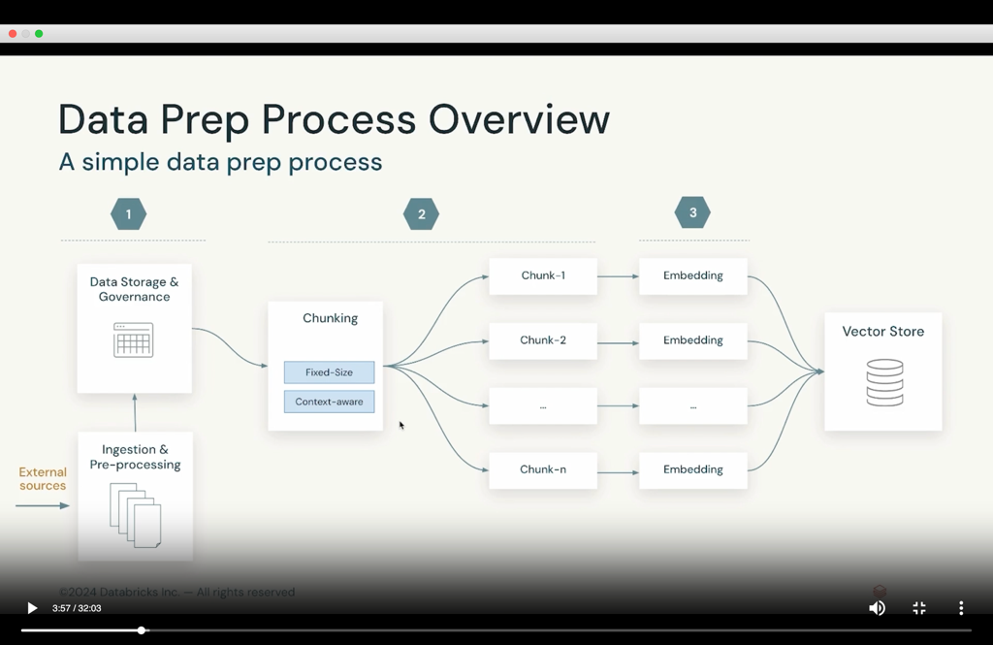
DATA STORAGE & GOVERNANCE –
- Delta lake – open unified data management layer that brings data reliability and fast analytics to cloud data lakes. It supports structured, semi structured, unstructured, streaming data. It is used when you input data is constantly updated and you want to make sure that you Rag is updated.
- Unity catalog (UC) – Unified visibility into data and AI, Single permission model for data and AI, open data sharing.
DATA EXTRACTION & CHUNKING –
Data/Document extraction – split documents into chunks, embed the chunks with a model, store them in a vector store. Risks are – chunks could be out of context, no overall logic.
How to chunk data ?
- Context aware chunking – Chunk by sentence/paragprah/section. Leverage special punctuation ('\n’). Include/inject metadata/tags/title
- Fixed size chunking – Divide by a specific number of tokens. Simple and computationally cheap.
Chunking is use case specific –
- If 1 chunk=1 sentence, embeddings focus on specific meaning.
- If 1 chunk = multiple paragraphs, embeddings capture broader theme.
- Chunk overlap defines the amount of overlap b/w consecutive chunks.
- Windowed summarization is a context enriching chunking method where each chunk includes a windowed summary of previous chunks.
- Prior knowledge to user’s query will be helpful.
Advanced chunking techniques –
- Take section1, summarize with LLM, then store to vector DB
Chunking challenges –
- Text mixed with image
- Irregular placement of text
- Color encoded focus
- Chart with hierarchical information
- Multi column text and order of columns is important
- Keeping images with related information is crucial
General approaches –
- Traditional approach – PyMuPDF, PyPDF
- Use a layout model – huggigng face, doctr, donut, unstructured – apply DL Models
- Use LLM – OpenAI GPT-4o, Gemini 1.5, Dolphin’s series, OpenFlamingo, Llama, OLMo
EMBEDDING MODEL –
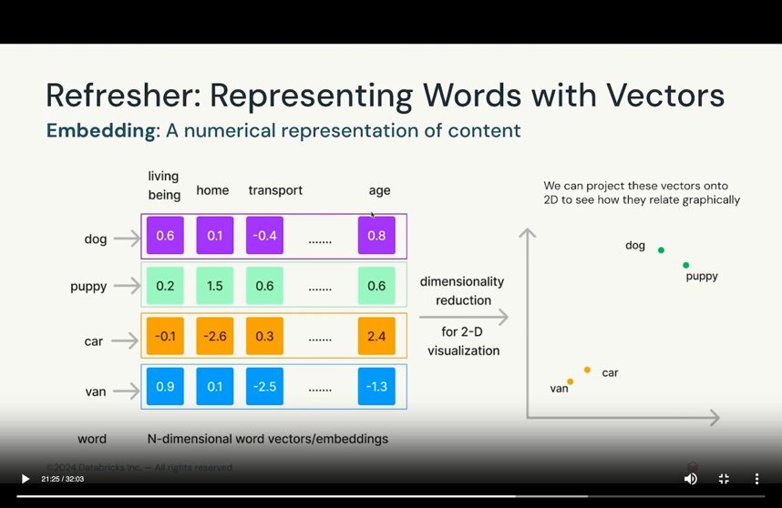
- Data/Text properties – Vocabulary size, Domain size, Text length
- Model capabilities – Multi language support, embedding dimensions
- Be aware of context window limitations.
- Privacy and cost licensing
- Benchmark multiple models and then select the best one
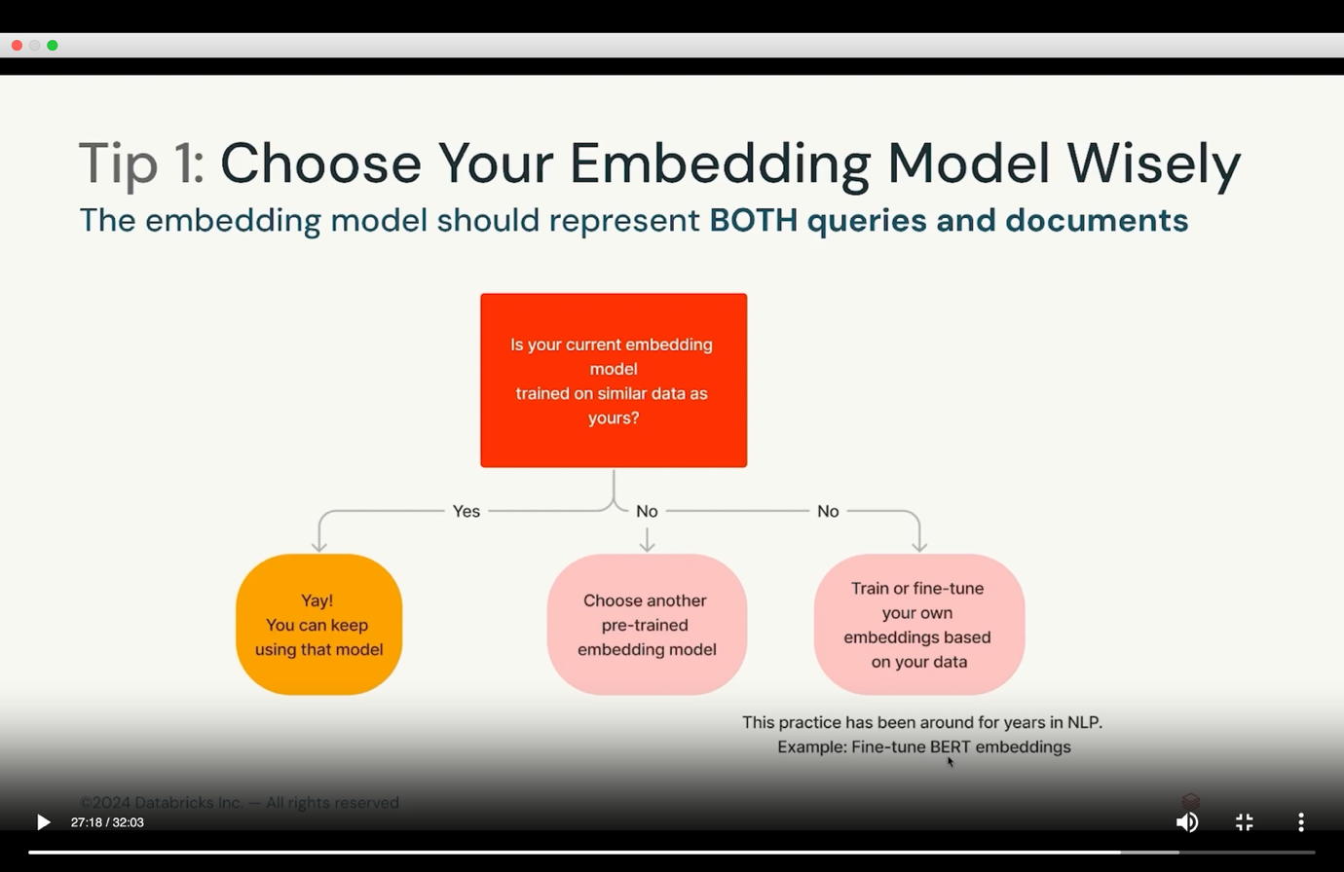
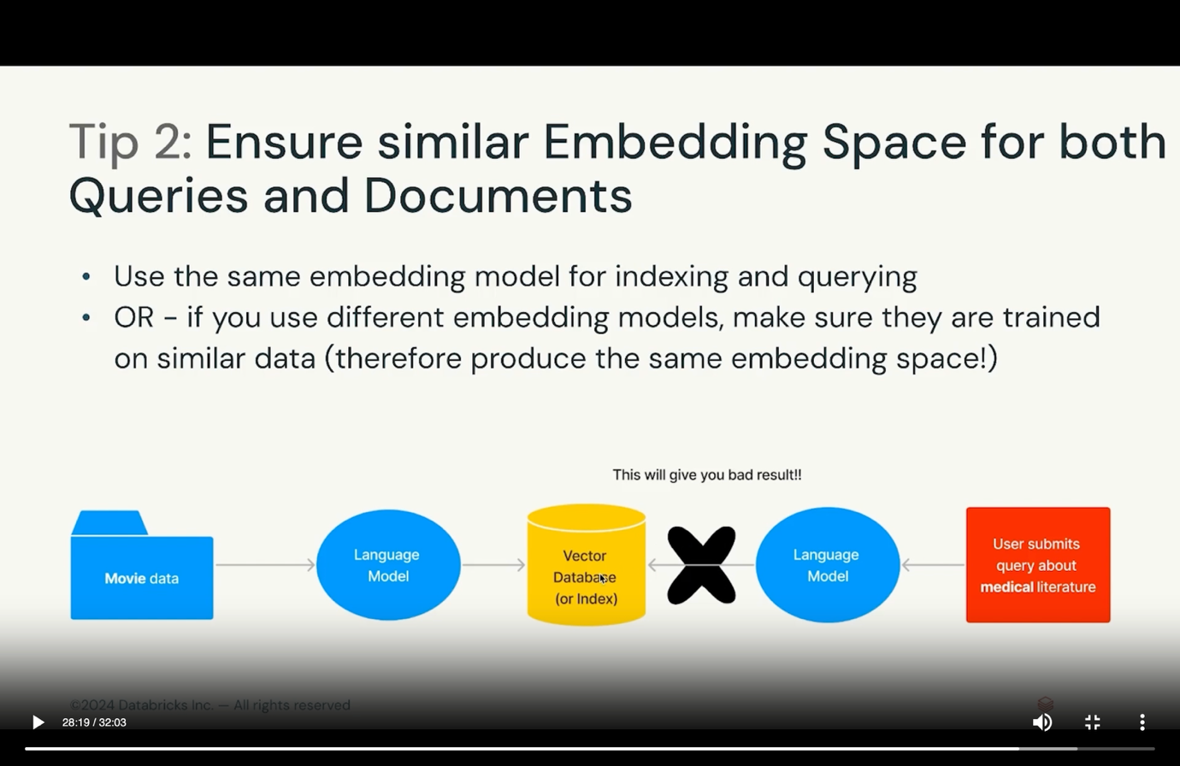
DATA PREPARTION IN DATABRICKS –
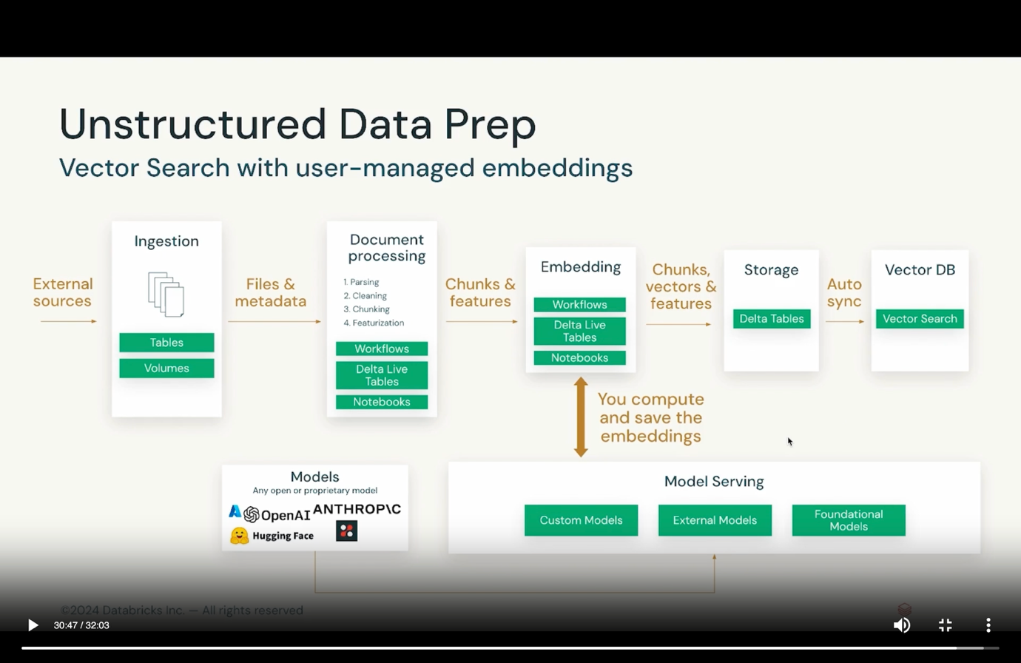
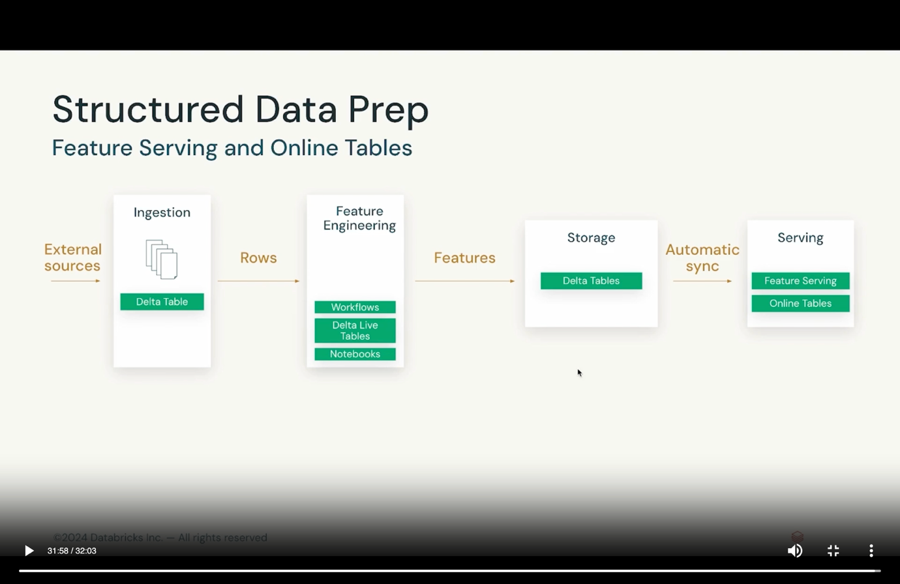
Module 3 – Vector Search
- Vector DB is a database that is optimized to store and retrieve high dimensional vectors such as embeddings.
- In RAG Architecture, contextual information is stored in vectors.
- Designed for efficient storage of vectors utilizied in gen ai applications, which rely on identifying documents or images with similarities.
- Vector db provide a query interface that retrieved vectors most similar to a specified query vector.
Vector db use cases –
- RAG
- Recommendation systems
- Similarity search
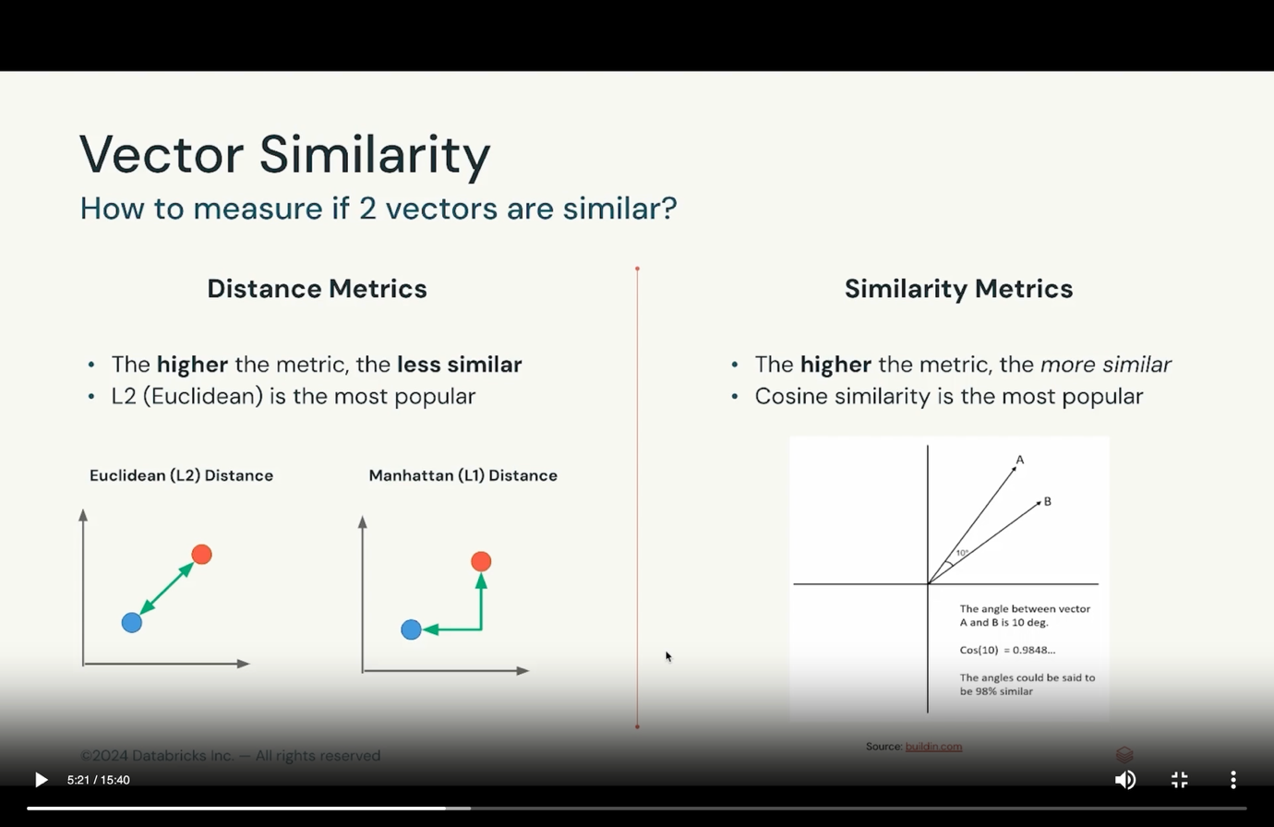
PROS OF VECTOR DB –
- Scalability – Million/Billions of records
- Speed – fast query time
- Full fledged database properties – Persistance & storage layer, CRUD API, ACL, Pre-Post Training
CONS OF VECTOR DB –
- One more system to learn and integrate
- Added cost
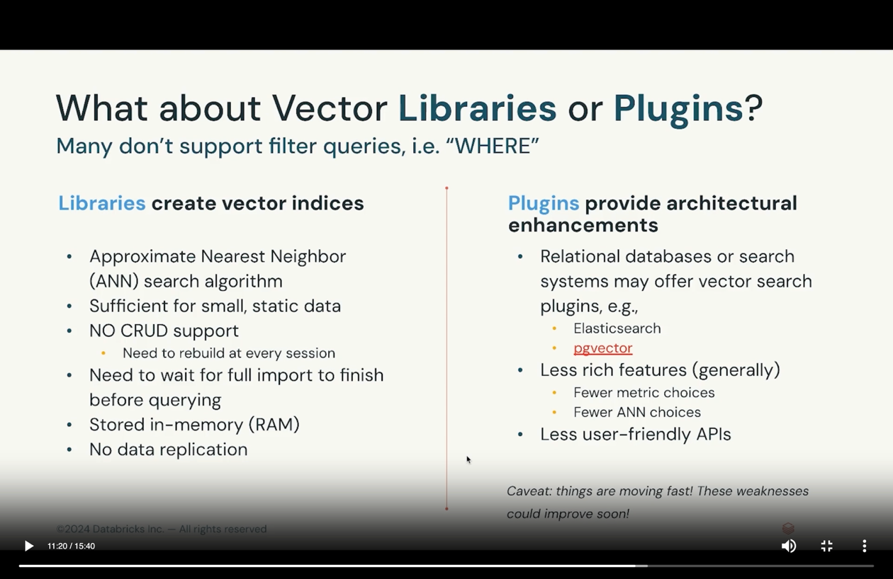
RERANKING –
- Reorder documents based on the relevance scores
- Goal is to place most relevant documents at the top of the list.
CHALLENGES OF RERANKING –
- LLM must be called repeatedly, increasing the cost and latency of the RAG chain.
- Implementing rerankers adds complexity to the RAG pipeline.
MOSAIC AI VECTOR SEARCH –
It includes an indexer, vector database, query engine, and an embedding model. It can help with operations like automatic synchronization and managed embeddings, creating vector search and model serving endpoints, and configuring a vector search index with auto-sync functionality.
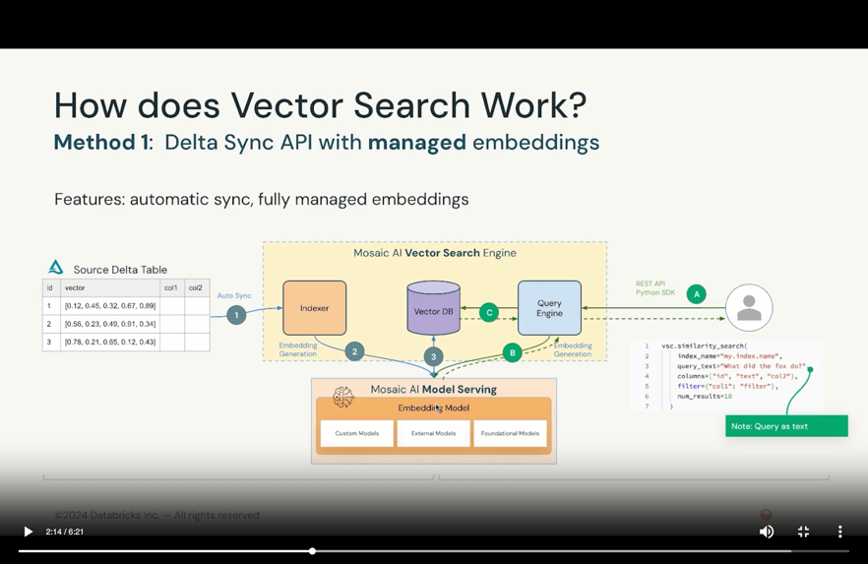
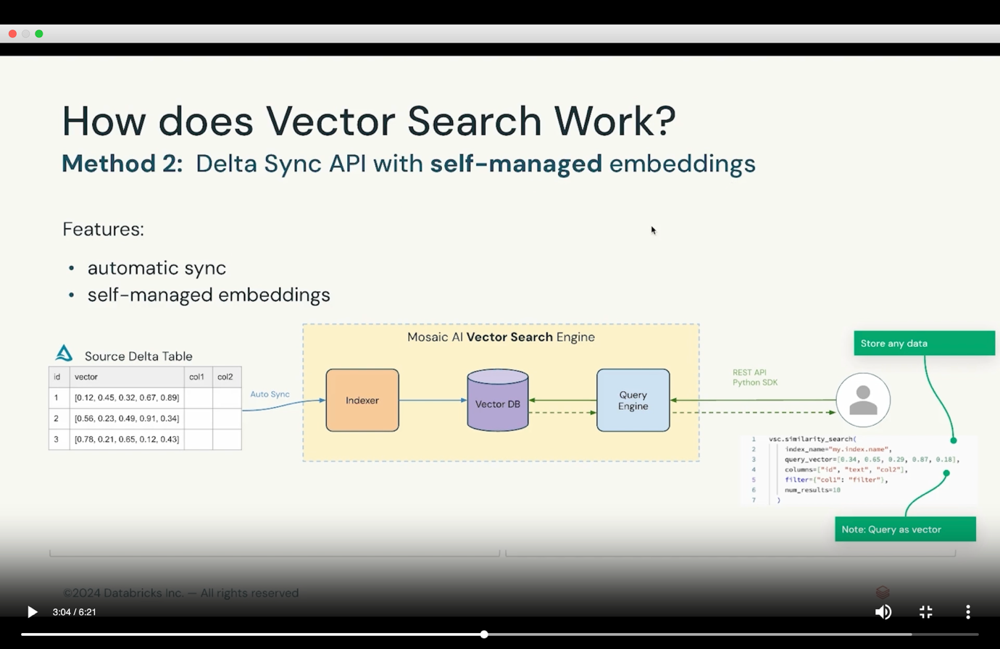
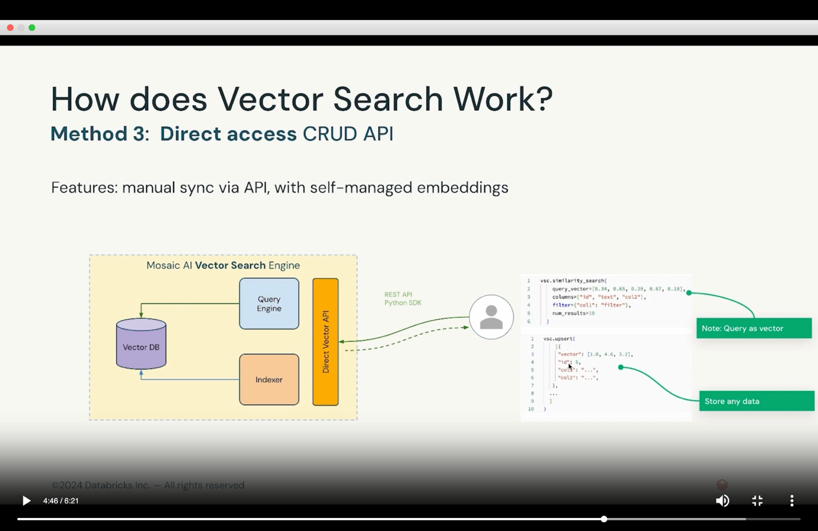
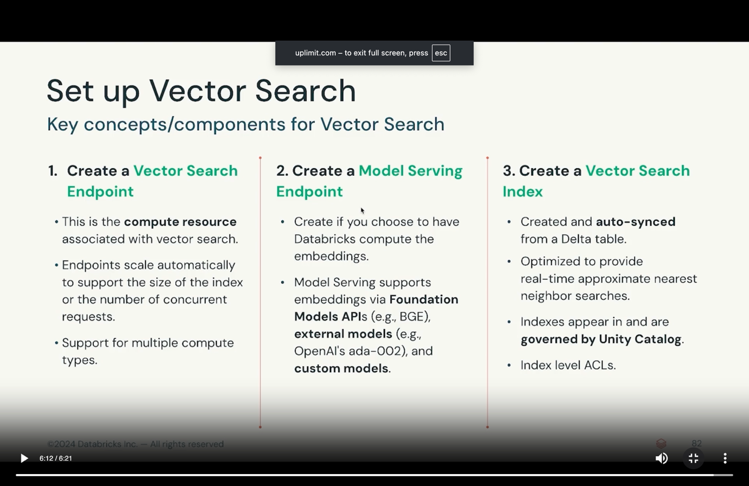
Module 4 – Assembling and evaluating RAG application
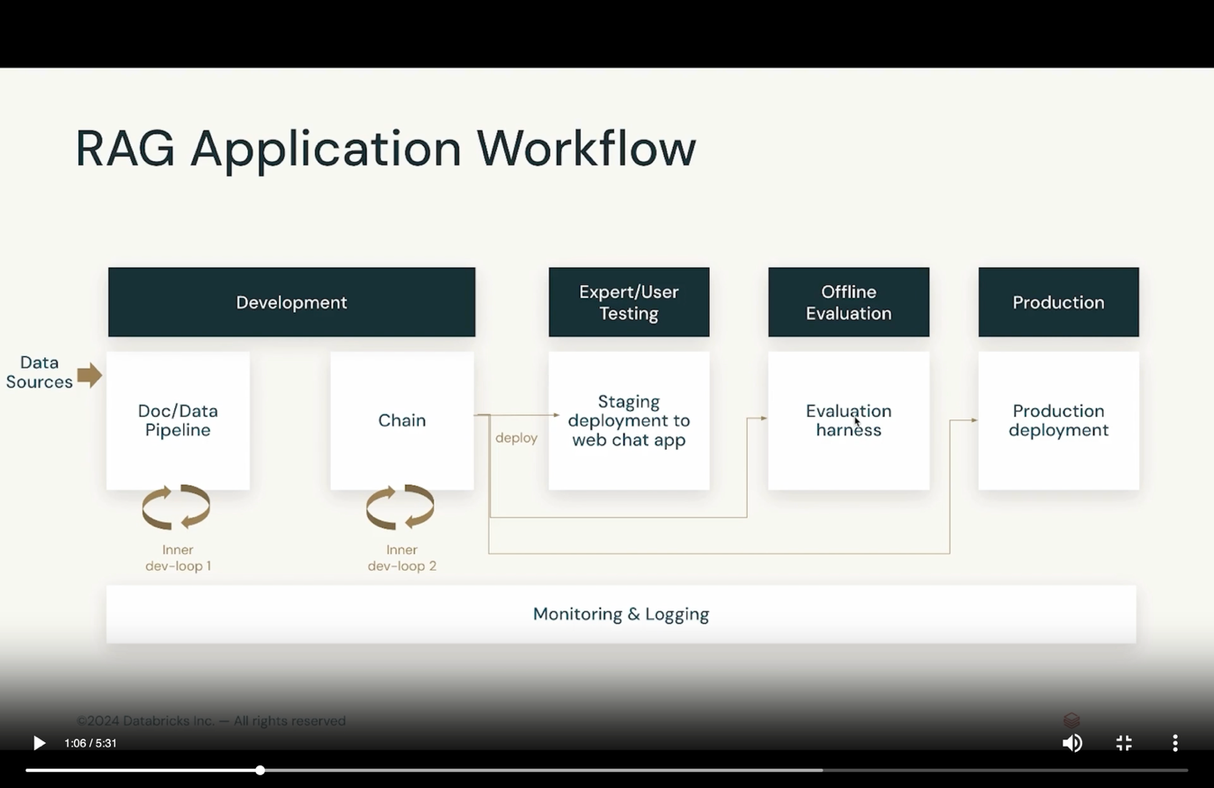
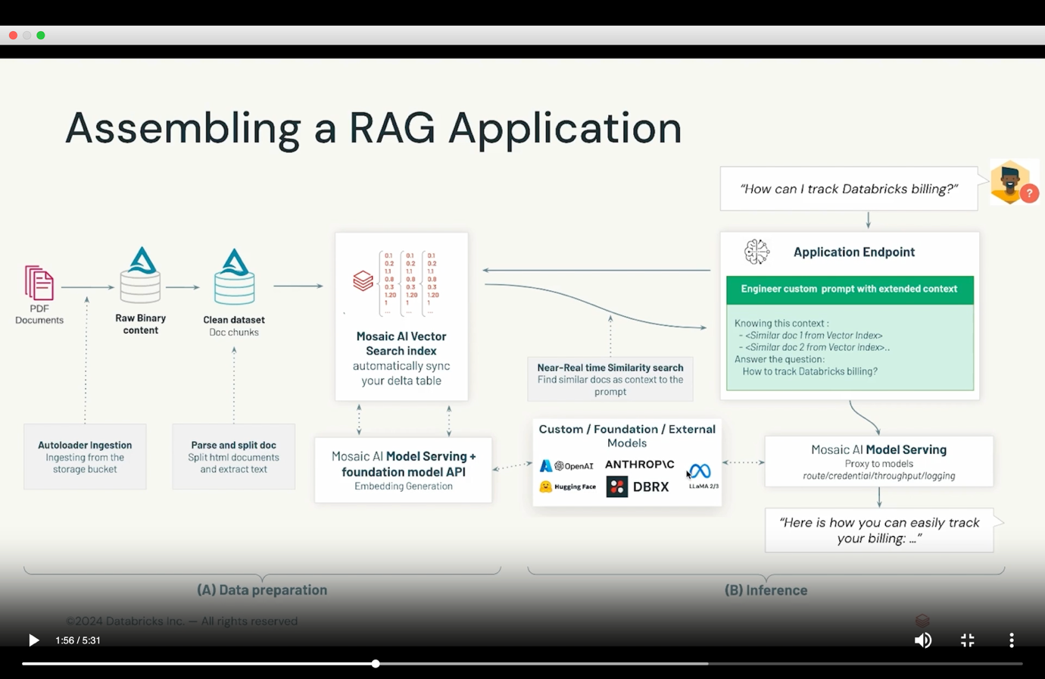
MLFLOW – Open source platform for ML lifecycle.
MLFLOW MODEL TRACKING –
- Record LLM parameters such as temperature and model configurations.
- Log metrics
- Store and manage output artifacts
- Store model’s source code from the run.
Module 4 – Evaluating a RAG Application
We need to evaluate each component separately and together.
Components to evaluate –
- Chunking – method, size
- Embedding model
- Vector store – retrieval and reranker
- Generator
Evaluation metrics –
- Is the context related to the query ?
- Is the response supported by the context ?
- Is the answer relevant and accurate ?
Context Precision –
- Signal-to-noise ratio for the retrieved context
- Based on query and context
- It assesses whether the chunks/nodes in the retrieval context ranked higher than the irrelevant ones.
Context relevancy –
- Based on both query and context
- It does not necessarily consider the factual accuracy but focusses on how well the answer addresses the posed question.
Context recall –
- Measures the extent to which all relevant entities and information are retrieved and mentioned in the context provided.
- Based on ground truth and retrieved context.
Faithfulness –
- Measures the factual accuracy of generated answer in relation to the provided context.
- Based on response and retrieved context.
Answer relevancy –
- How applicable the generated response is to user’s initial query
- Based on response and query
Answer correctness –
- Measures the accuracy of generated answers when compared to ground truth
- Based on ground truth and response
MLFlow evaluation –
- Batch evaluation in code – LLM as a judge
- Interactive evaluation in UI – Compare multiple models and prompts visually. Iteratively test new queries during development.

Week2 -Class
SHIFT FROM MODELS TO COMPOUND SYSTEMS (Chain)
RAG is an AI system composed of a single task.
A system that tackles AI tasks using multiple interacting components, including multiple calls to models, retrievers, or external tools.
Langchain – A software framework that behaves as a compound system for Gen AI Applications. It will behave as a LLM, retrieve. We have langchain/Llamaindex. One of the oldest.
Search on google for langchain tools.
Langchain components – Prompt, chain, retriever,Tools
LLamaindex components – Models, prompt, indexing and storing, quering, agents
Choosing a library –
- Features
- Performance & security
- Stability & complexity
Non agentic workflow – more hardcoded, whatever query comes, every time same sequence of tasks will be running as per the business logic.
Agentic workflow – flexible and complex to build.
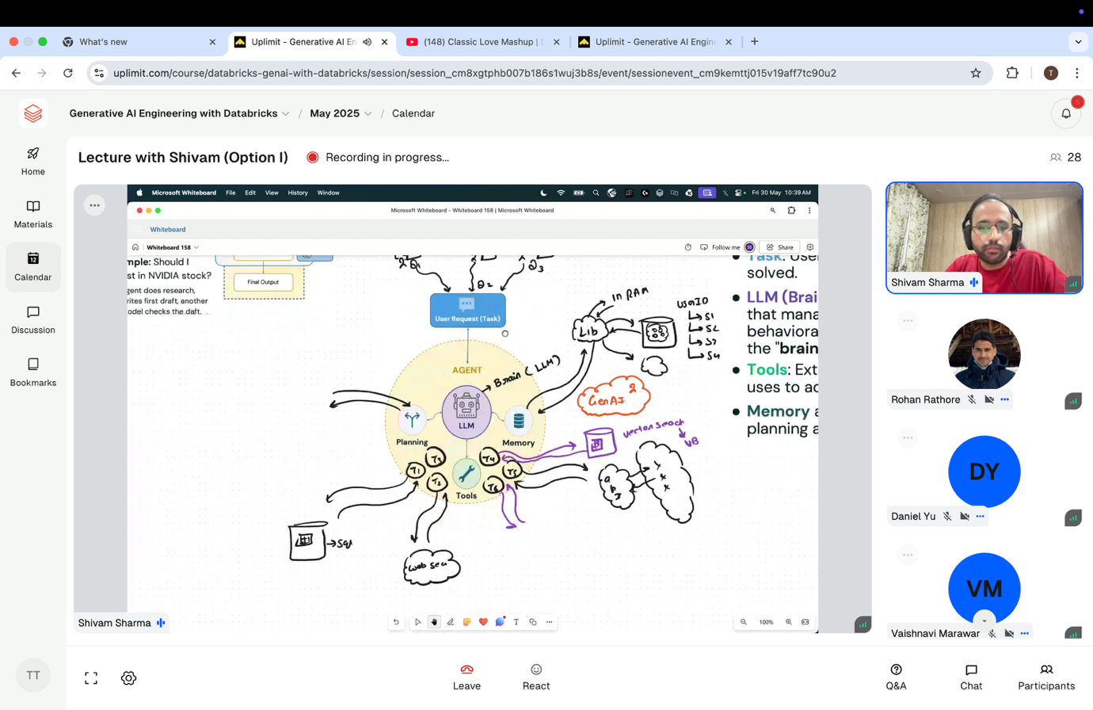
Q1 => t1, t2,t3
Q2 => t3,t1,t2
Q3 => t1,t3,t2
Here, in agentic workflow, sequence of tasks will be taken care by the LLM basis on the nature of the query.
Agent reasoning pattern
- ReAct – Thought, act, observe
- Function calling – Agents react with external tools/APIs to perform specific tasks
- Planning
- Multi agent collaboration - https://arxiv.org/pdf/2307.07924 - To create this, you can use LangChain, LangGraph, LlamaIndex (1 LLM – Multiple agents OR Multiple LLMs, Multiple agents)
Module 1 – Foundations of Compound AI Systems
RAG is an AI system composed of a single task.
A system that tackles AI tasks using multiple interacting components, including multiple calls to models, retrievers, or external tools.
Example 1– Real world prompts have multiple intents
Objective – Analyze the sentiment for a Japanese customer review.
Intents –
- Translate Japanese customer review into English.
- Summarize the translated text
- Analyze its sentiment.
- Classify the type of feedback provided
System, Intent, tasks –
- System – Create a personalized response to a customer’s question.
- Intents – Identify the question type, identify the language.
- Tasks – Retrieve customer purchase history, Create a message
Chains – Applications with more than a single interaction.
Chain starts -> task 1 -> task 2 -> task 3 -> task 4 -> chain completed
Example – For sentiment analysis, we can split the tasks – task 1-> summarize the content. Task 2 -> analyze the sentiment of those summarized tasks.
APPLICATION DEVELOPMENT LIFE CYCLE –
- Analysis – Define the project’s objectives and user requirements
- Design – Outline the architecture, structure and behaviour of the system.
- Development – Coding and building of the system
- Production – deployment of the system into production.
- Monitoring – assessing the performance, usability and effectiveness of the deployment system against benchmark criterion.
INTENT CLASSIFICATION AND CHAIN BUILDING –
- Identify intents – Define possible intents based on user queries.
- Identify tools – Web search, API integration, coding, text to sql, etc.
- Build the chain – Build a workflow based on identified tasks.
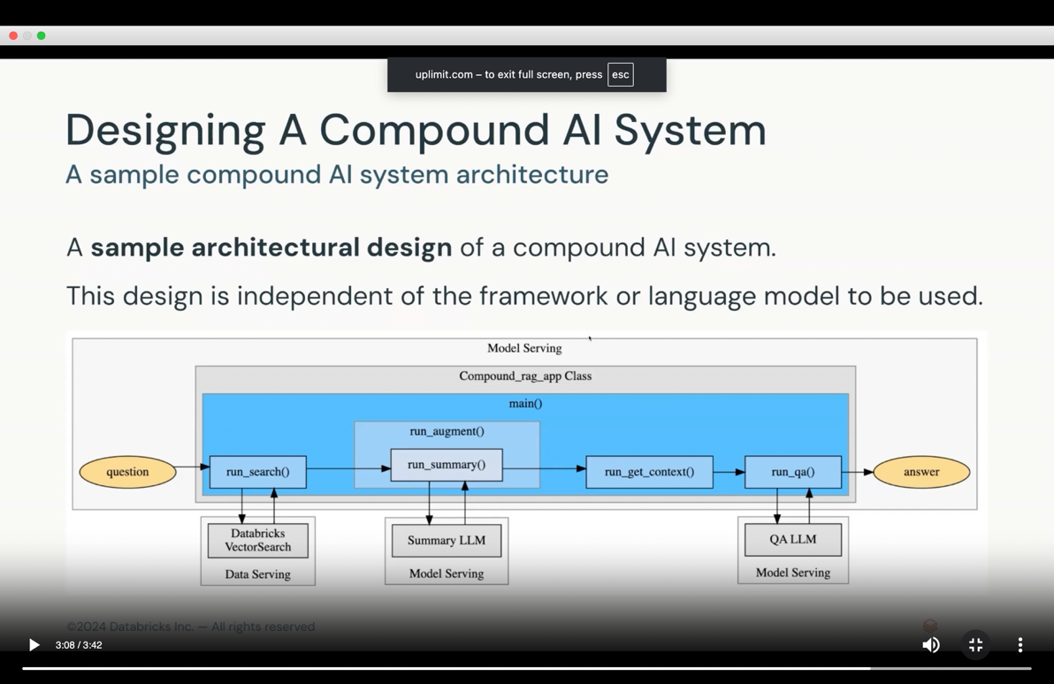
Module 2 –

Week 3
Module 1 – Data legality
- Why to evaluate ?
Is it behaving as expected
Are users happy with the results
is our llm solution effective
is there bias
what is the costing
Data components –
- Raw documents
- Vector database
- Input/output
Model components –
- Embeddings model
- Generation model
Other components –
- Vector search
- User interface
- Security/governance
We need to evaluate the whole application as well as the individual components.
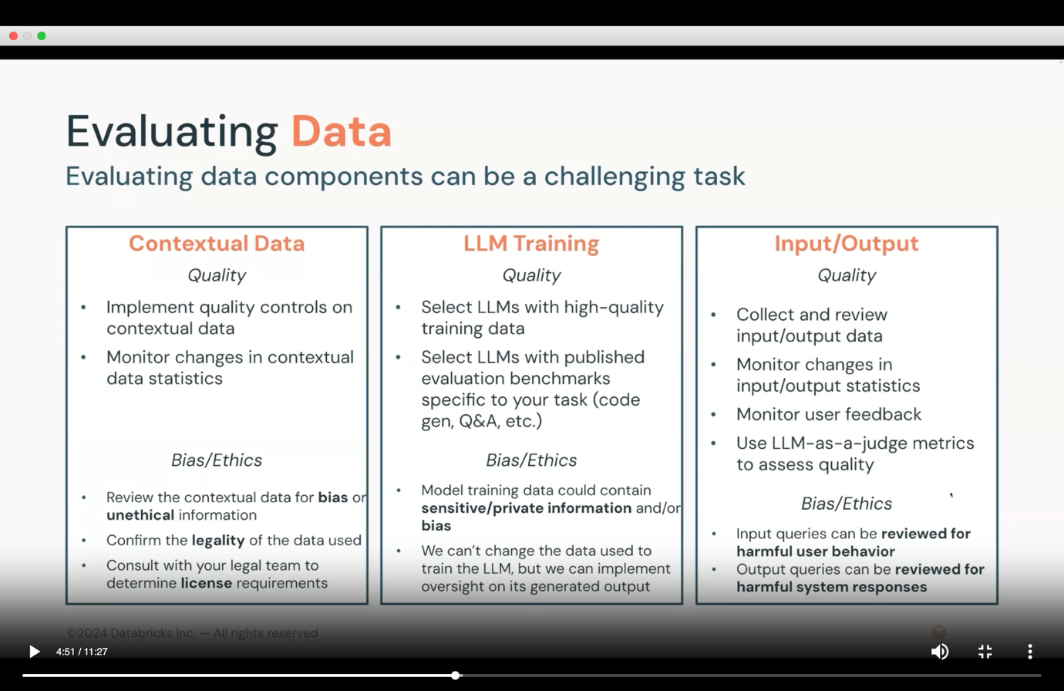
Issue: Data legality –
- Who owns the data?
- Is your application for commercial use?
- In what countries/states it will be deployed?
- Will your system generate profit ?
Issue: Harmful user behaviour –
- Users can import prompts to override system’s intended use
- Prompt injection be used to extract private information
Issue: bias/ethical issue –
- LLM can prompte ideas that were present in the data they were trained on
- This can result in unintended bias
How to mitigate the above issues ?
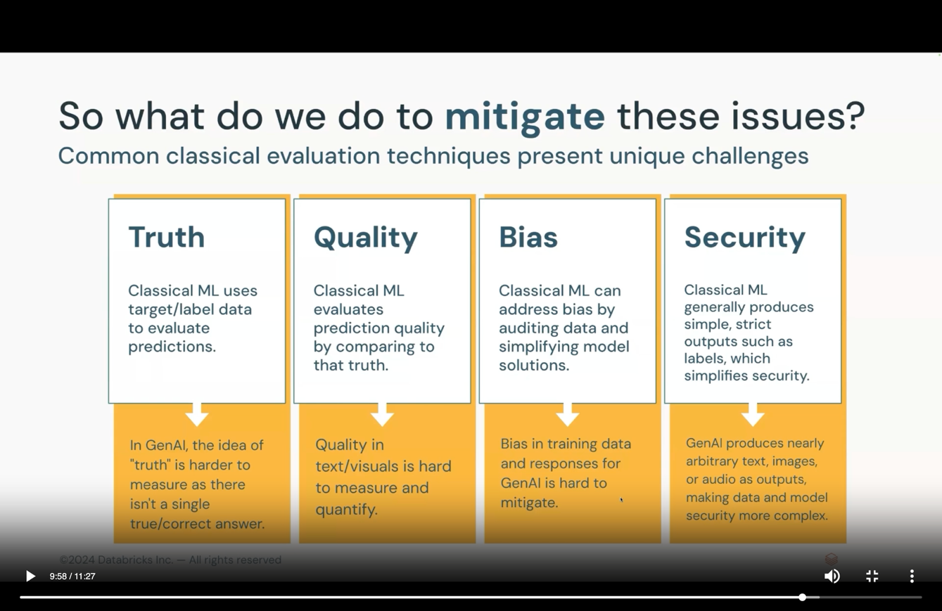
A systematic approach to gen ai evaluation –
- Mitigate data risks with data licensing and prompt safety and guardrails
- Evaluate llm quality (next module)
- Secure the system (third lesson)
- Evaluate system quality (last lesson)
Prompt safety and guardrails – Responses can be controlled by providing additional guidance to LLMs called guardrails. Eg. – input – do not tell steps to do any crime/commit suicide.
Module 2 – securing and governing AI Systems
Why is it important ?
- Data access, governance and lineage
- Model tracking, evaluation and audit
- Harmful acts like injection
- Exposure of secure information and assets
- Quality monitoring for various drift
Why is it challenging ?
- Data scientists haven’t done security
- Security teams are new to AI
- ML engineers have worked with simpler architecture
- Production introduces new real time security challenges
If we want to secure AI application with RAG, we need to secure data components, input query, embedding model, vector database, output query.
Data and AI security framework (DASF) – Organizing the AI security problem with a component based framework. It will give 12 AI system components and 55 associated risks.


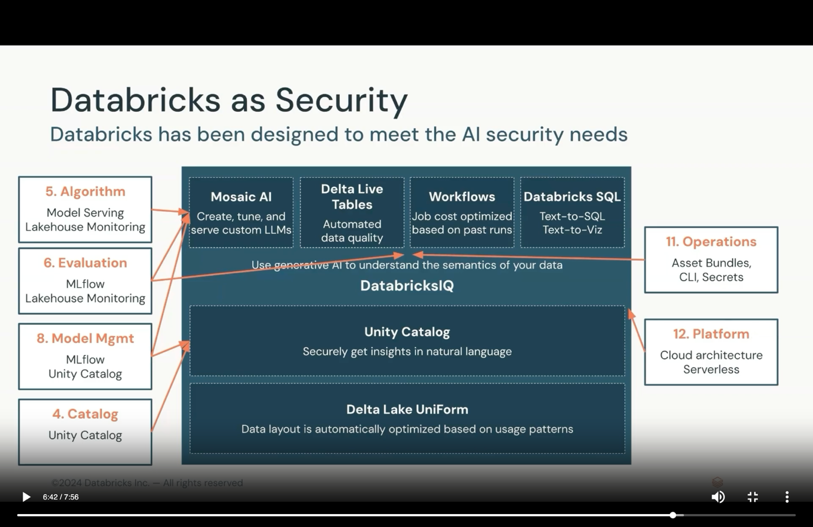
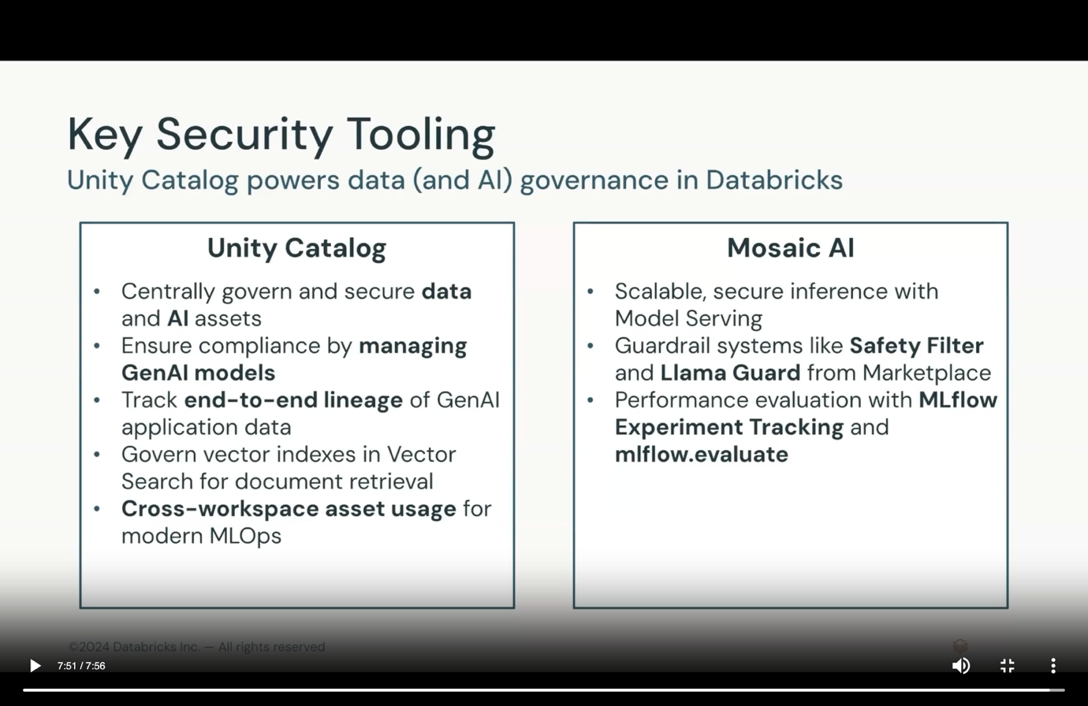
Module 3 – Gen AI Evaluation techniques
Classical ML –
- Less expensive storage and compute hardware
- Evaluated by clear metrics (F1, accuracy).
- Often provide interpretable scores.
LLMs –
- Requires massive amounts of data (GPU,TPU)
- Evaluated using language specific metrics (BLEU, ROUGH, Perplexity, human judges, llm as a judge)
LOSS (Base foundation model metrics) –
- Difference b/w predictions and the truth.
- We can measure loss while training llm by ow well they predict the next token.
- Issue is llm will make predictions, but not be very confident. They can hallucinate.
- We can’t compute accuracy.
PERPLEXITY (Is the model surprised that it was correct) –
- Low perplexity = high confidence
- High perplexity = low confidence
- A sharp peak in the language model’s probability distribution reflects a low perplexity
TOXICITY (How harmful is the output of the model ) –
- Used to identify and flag harmful, offensive or inappropriate language.
- Low toxicity = low harm
- Eg. They are so nice=0.1….this person deserves = 0.9
Limitations of these tasks –
- These techniques are good overall, but they are not task specific.
- In real time, applications will focus on tasks – like content generation, summarization, translation.
- Do any of our metrics evaluate how well an LLM completes these tasks ? We have BLEU and ROUGH.
BLEU –
- Bilingual evaluation understudy
- BLEU compares translated output to a references, comparing n-gram similarities between the output and the reference.
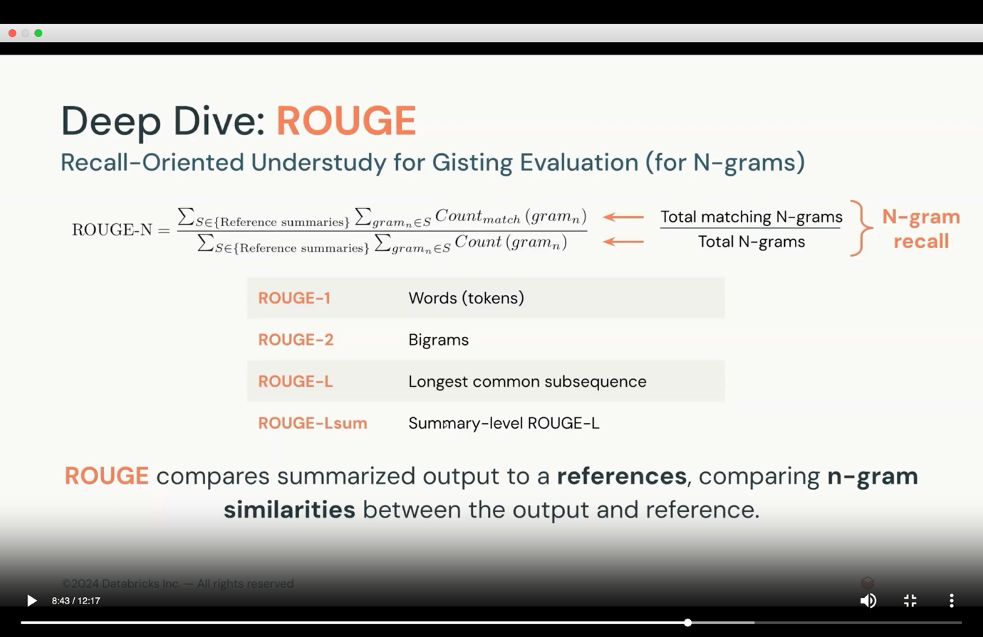
What do these BLEU and ROUGE have in common ?
- They are task specific metrics
- They are applied to LLM output
- They consider n-gram output rather than unigram
- They compare to reference datasets
Benchmarking –
- Comparing models against standard evaluation data sets
- You can use large generic datasets or curate your own.
Evaluation limits –
- What if we don’t have a reference dataset ?
- Our task doesn’t have existing api or metrics
- We need to evaluate outlying cases
- LLM-as-a-judge will solve the above 3 issues
LLM-as-a-judge –
- It can use prompt engineering templating
- Use few-shot-examples with human provided scores for more guidance
- Provide more specific instructions of what good looks like
- Provide a component based rubric or more specific evaluation scale
ML Flow LLM-as-a-judge capabilities –
- Create example evaluation records
- Create a metric object, including the examples, a description of the scoring criterion, the model used, and the aggregations used to evaluate the model across all provided records.
- Evaluate the model against a reference datasets with newly created metrics.

Week 4 – Class
MLFlow – will create a package whichever framework you use.
Deployment paradigms –
- Batch – dbks workflow – batch output and bulk output. Throughput and latency is high
- Streaming – delta live table – micro batches are there, we can control the size of micro batch. Throughput and latency is moderate.
- Real time – model serving. Api calls. Eg. Chatbot. Latency is low
- Edge/embedded – on premise deployment. Any type of IOT based deployment. Databrick don’t do this
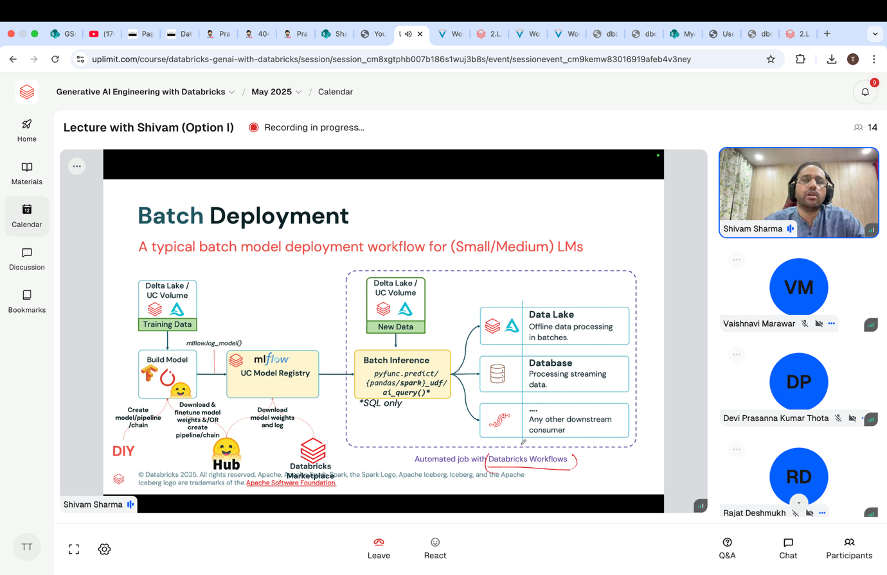
Batch inference from sql using ai_query()

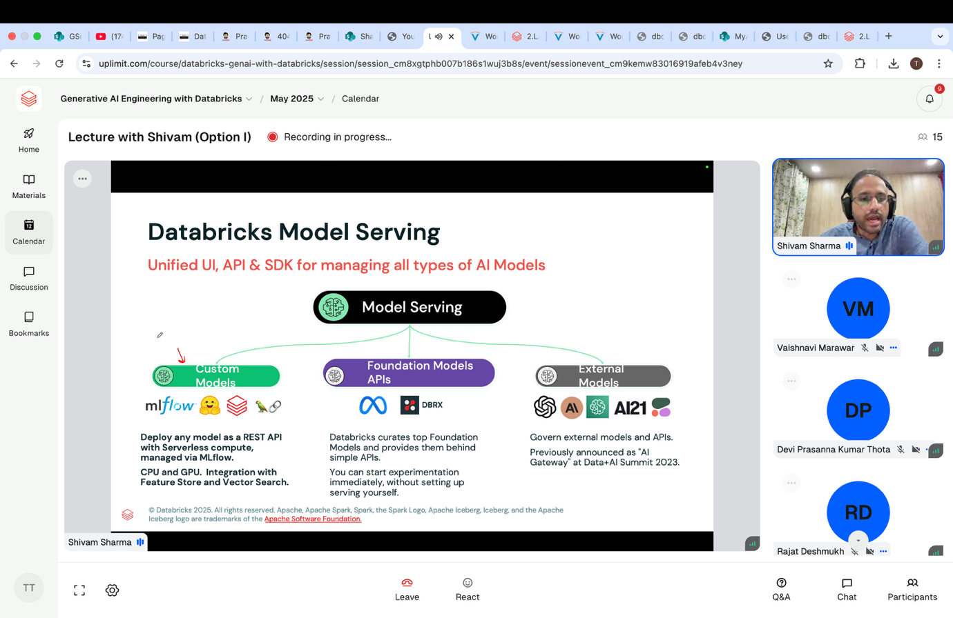
Lakehouse monitoring – to monitor your deployed application
Databricks asset bundle – very important

Week 4 – Deployment and monitoring
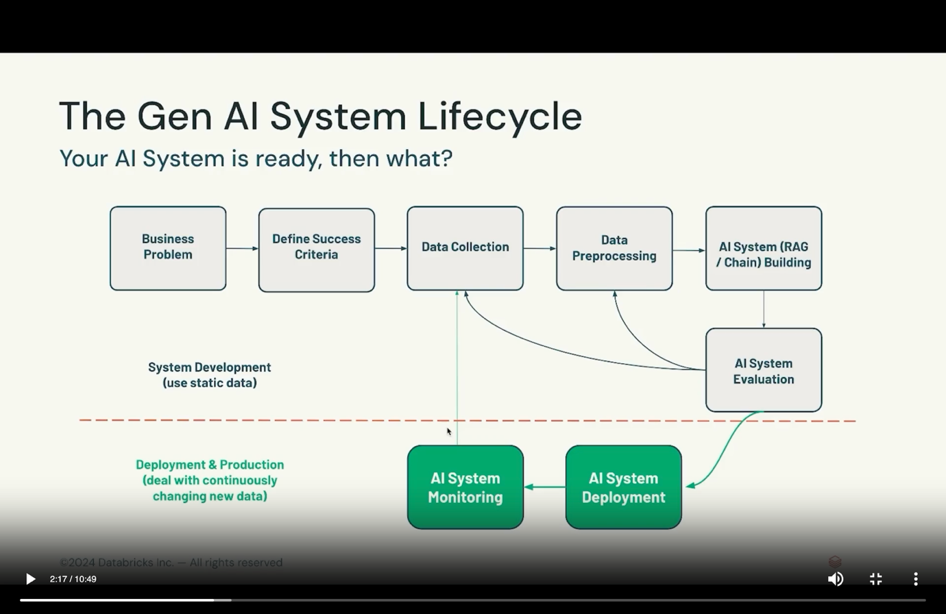

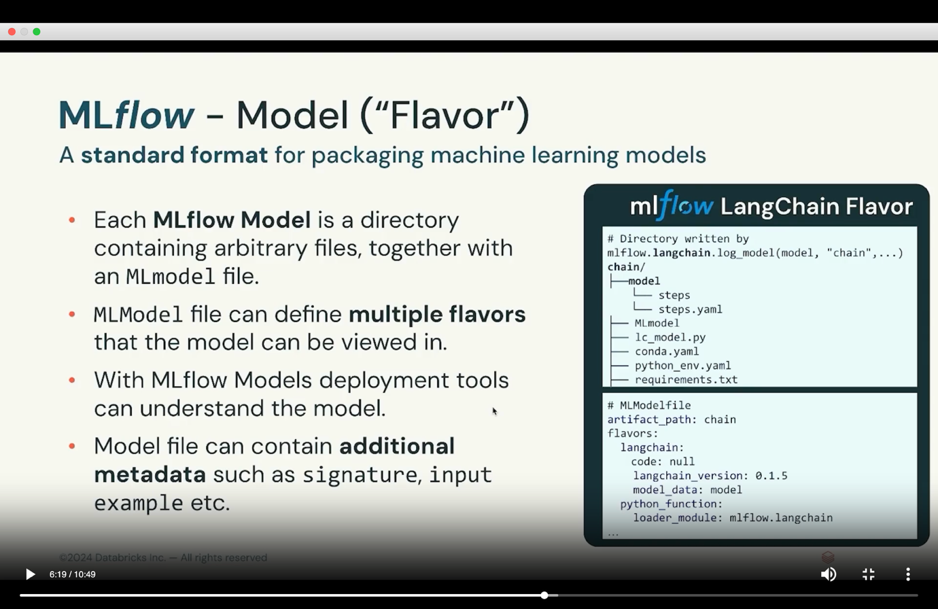
By default, we have mlflow.pyfunc model.
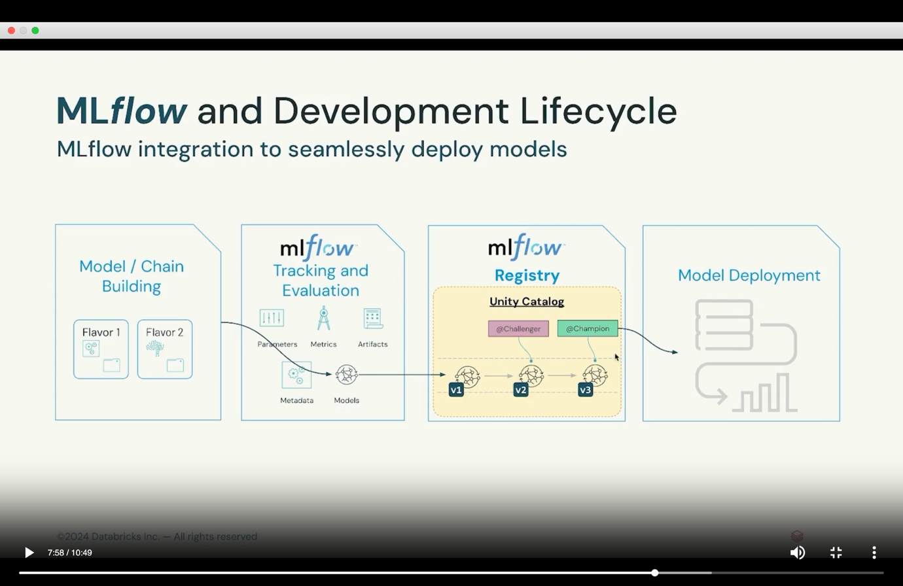

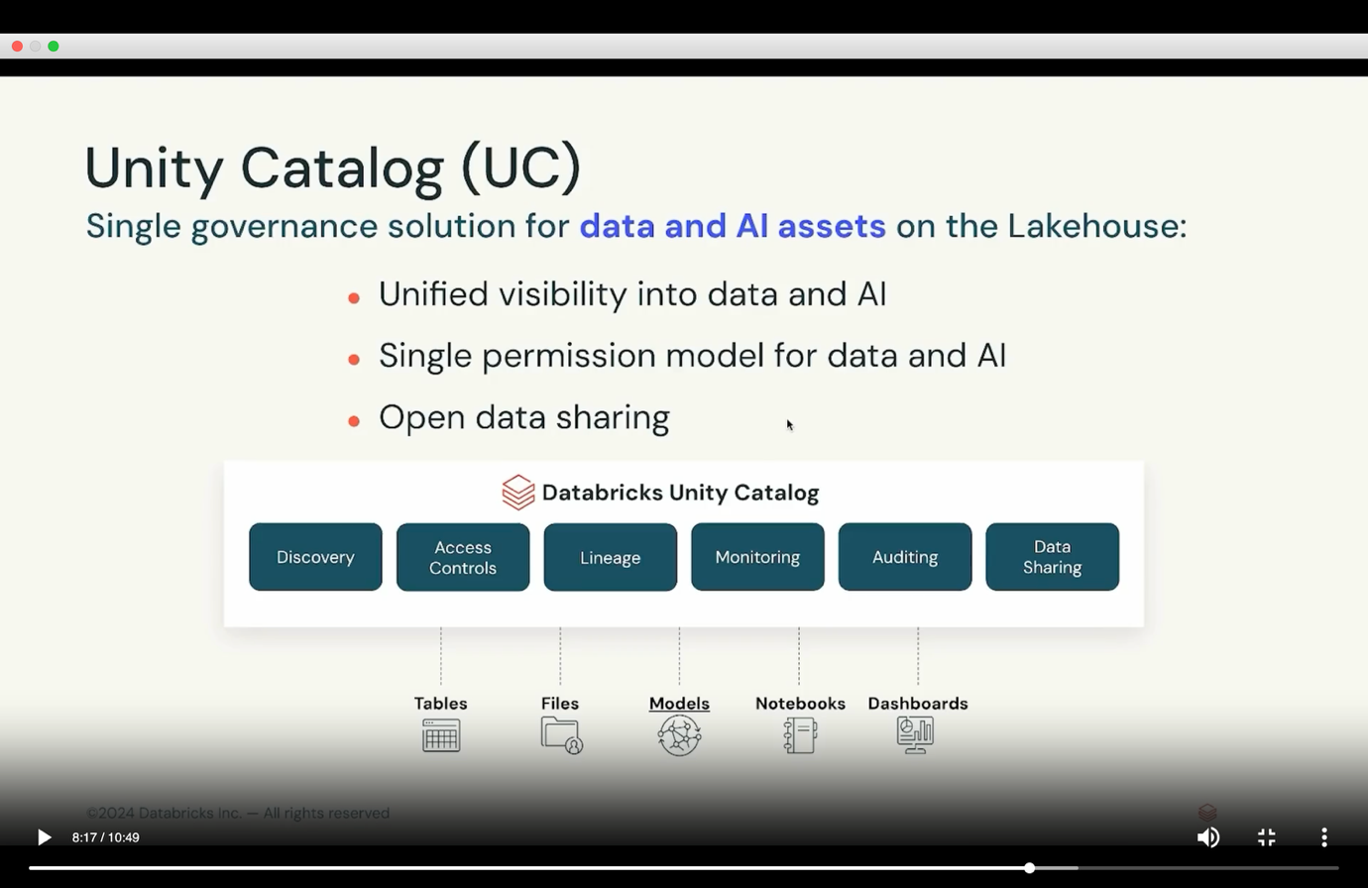
Unity catalog model registry – model lifecycle management with versioning and aliases.
Benefits of mlfLOW –
- Ensures that deployment environment matches the training environment.
- Any code and configuration are packaged.
- Built in local flask server with ML Server.
- Databricks model serving.
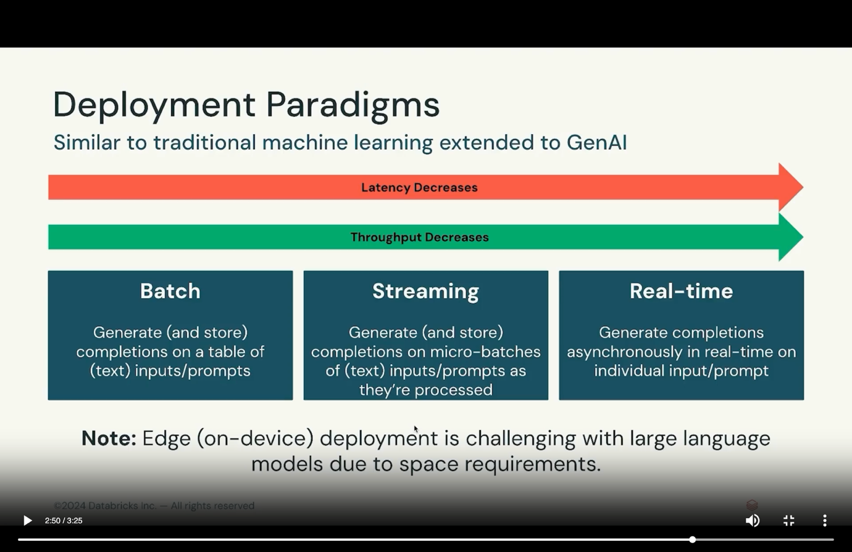

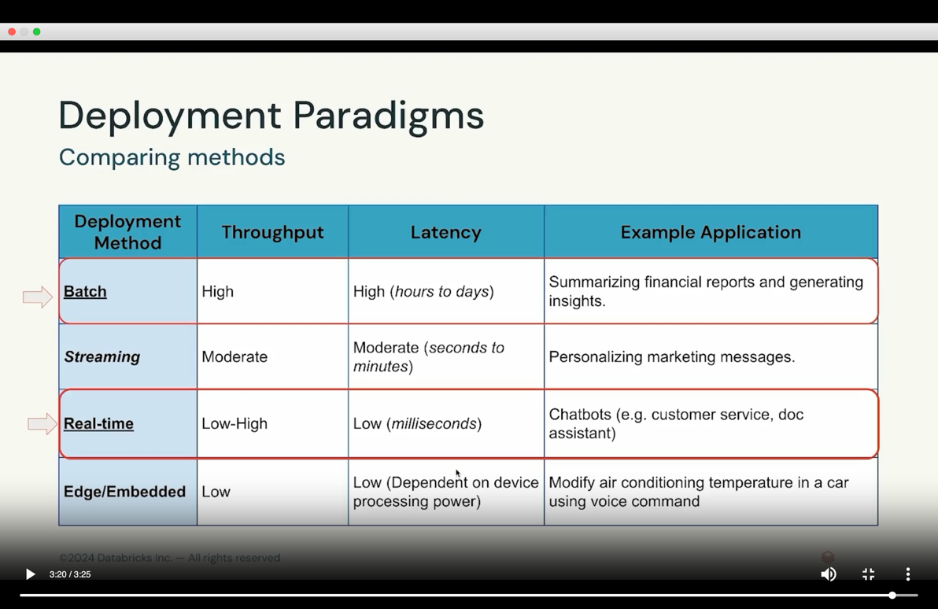
Module 1 – Batch Deployment
Batch deployment involves processing data in bulk at scheduled intervals rather than in real-time. It is useful for tasks like nightly updates or periodic analyses, where immediate processing is optional. This method allows for efficient handling of large datasets, but can introduce delays in data processing and model updates.
Example – daily tasks like eip data pull, and doing preprocessing.
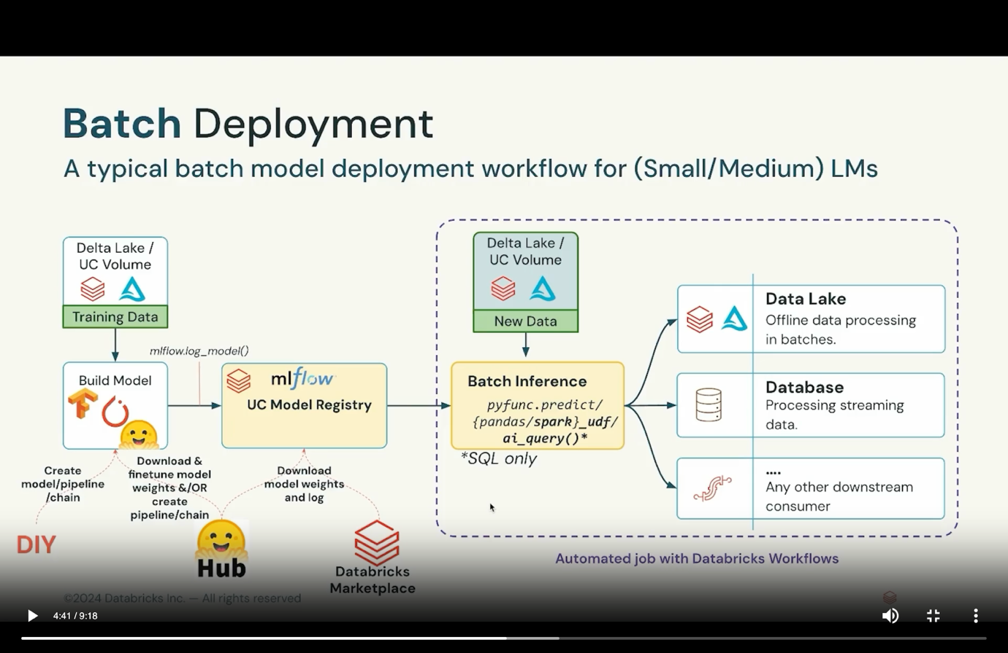

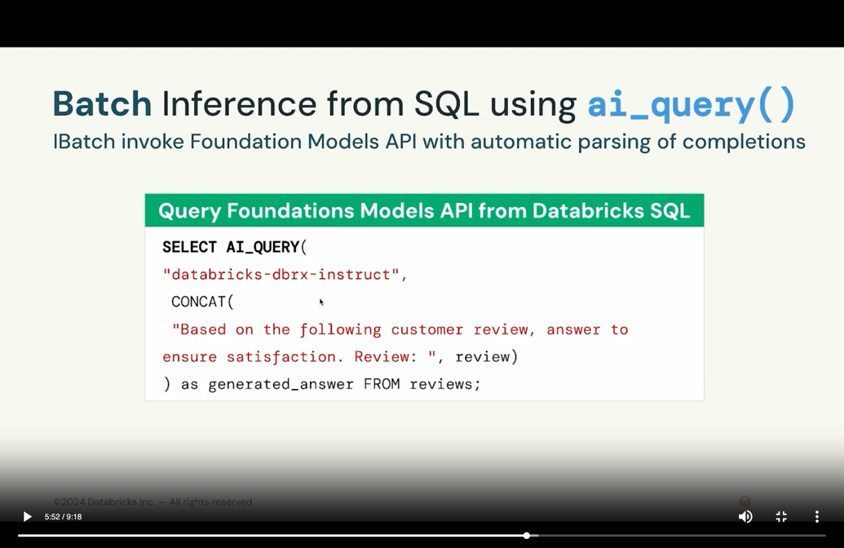
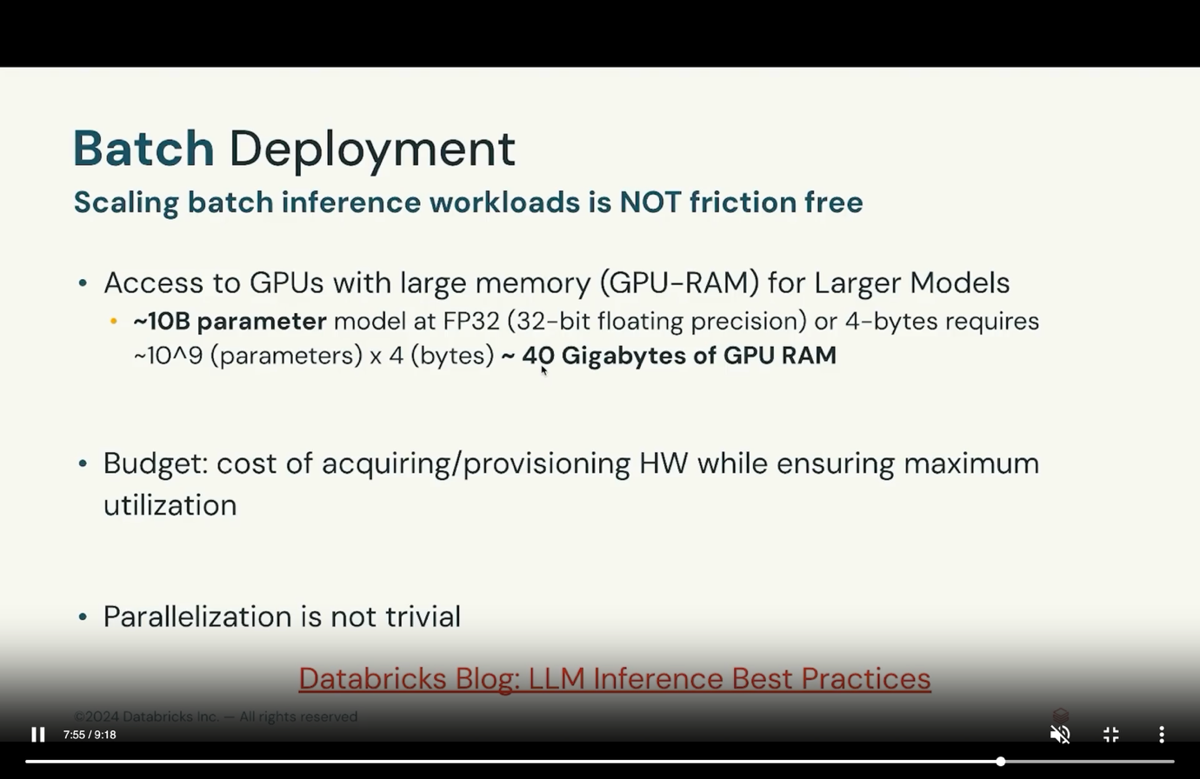
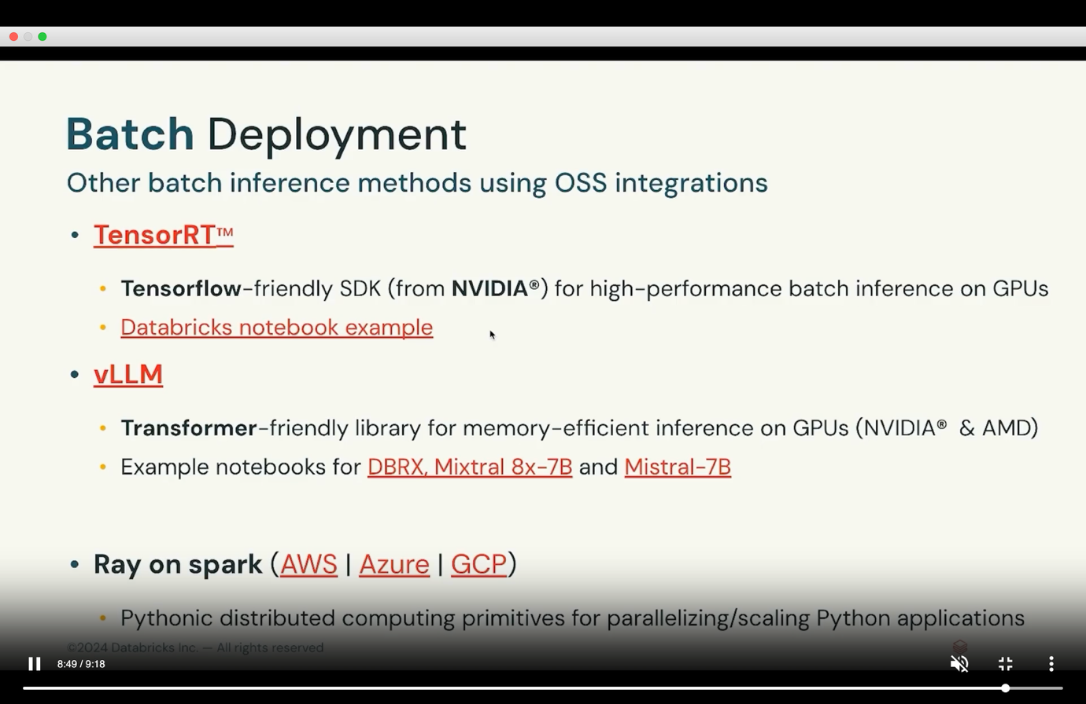
Module 2 – Real time deployment
Use case – real time intent detection for social media platform. It needs immediate classification, if it is toxic/harmful/sexual, it is removed immediately. It is used when we need low latency, immediate action, 24/7 uptime, continuous monitoring. 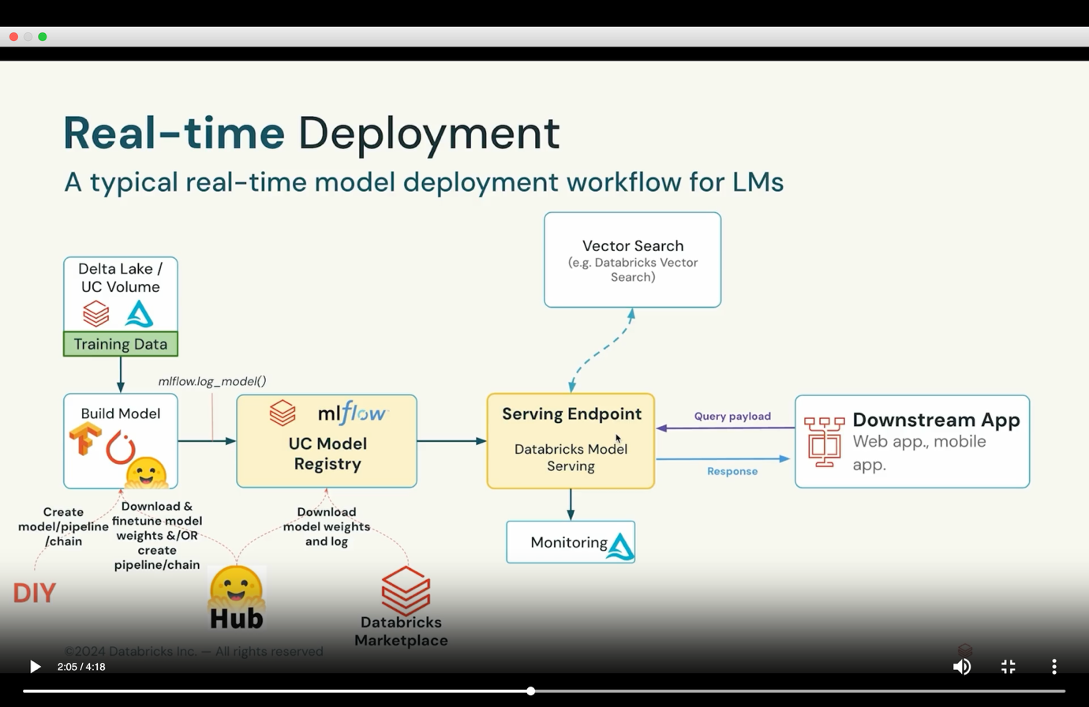
Challenges with realtime deployment –
- Infrastructure is hard
- Needs diverse tools
- Steep learning curve of development tools.
Databricks model serving –
- Highly available
- Accelerate deployment
- Simplified deployment
Databricks model serving –
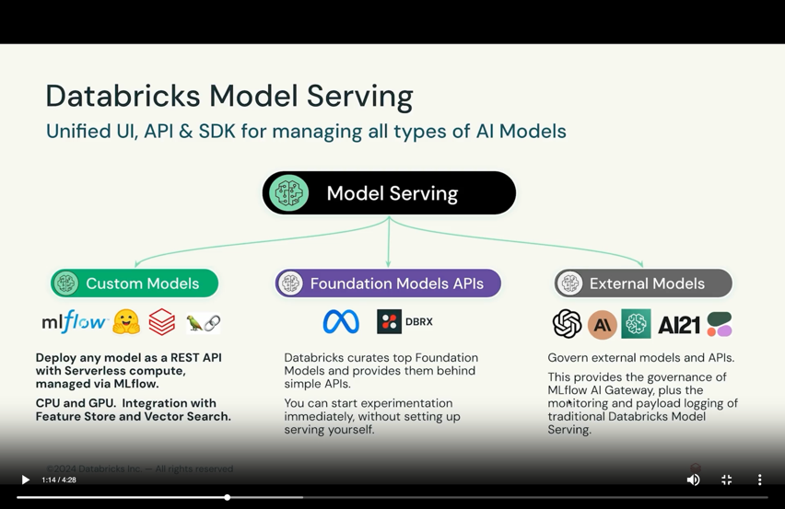
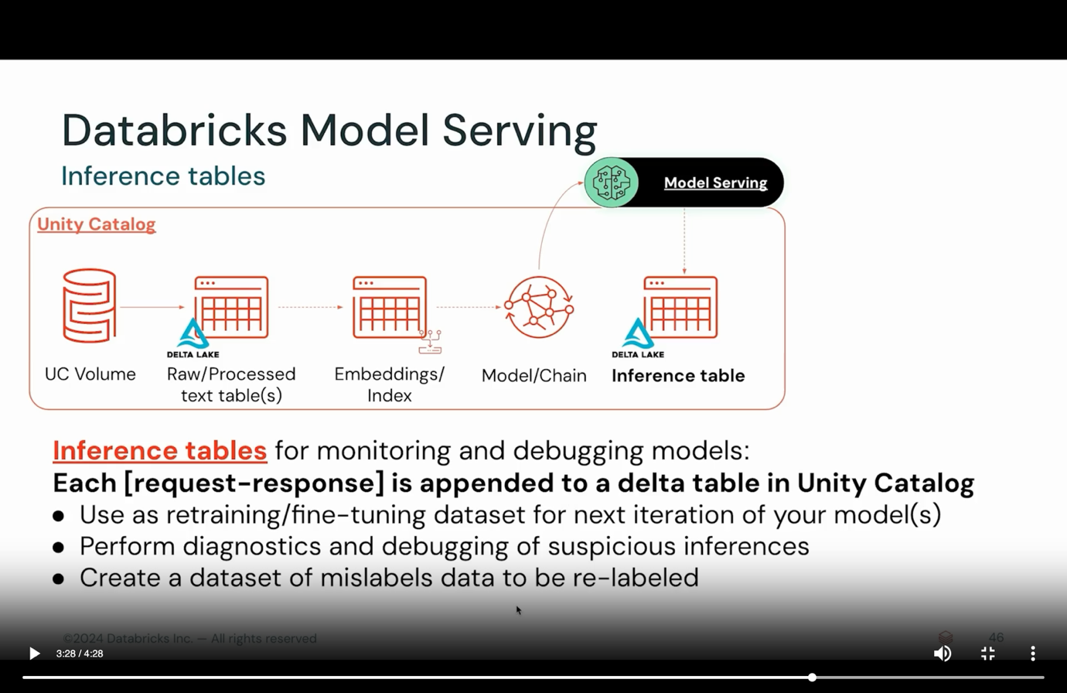
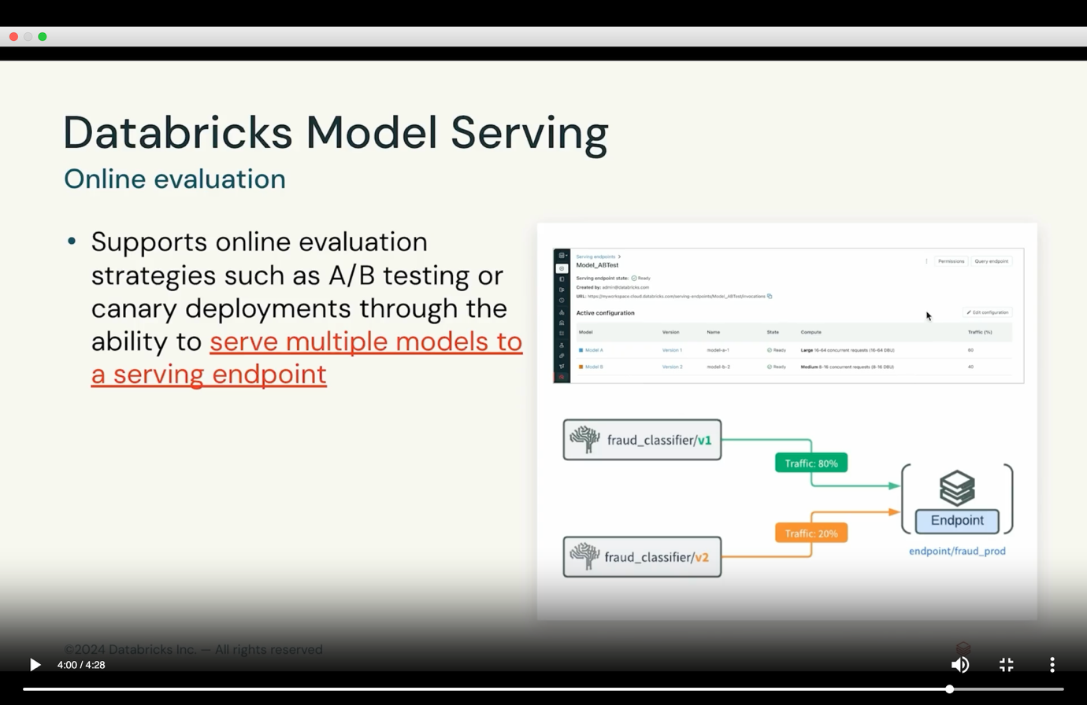
https://www.databricks.com/learn/training/certification#certifications
https://www.databricks.com/learn/certification/genai-engineer-associate
https://www.databricks.com/sites/default/files/2025-04/databricks-certified-generative-ai-engineer-associate-guide.pdf
Module 3 – AI System monitoring
Data to monitor - input data, data in vector databases, knowledge bases, human feedback data, queries, responses.
AI assets to monitor – mid training checkpoints for analysis, component evaluation metrics, ai system evaluation metrics, performance/cost details
Databricks lakehouse monitoring –
- Fully managed so no time wasted on infrastructure
- Frictionless with easy setup
- Unified solution for data and models for holistic understanding
Built on utility catalog, for each monitored table –
- Calculates profile metrics table
- Calculates drifts metrics table
- Supports custom metrics as sql expressions
- Auto generates dbsql dashboard
- Automatic PII detection
- Input expectations and rules
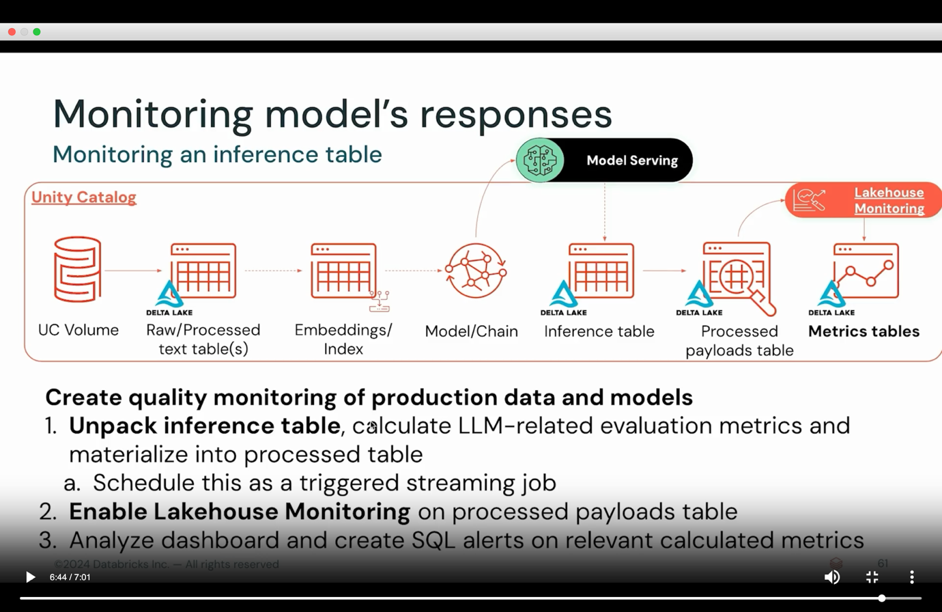
Voucher Code: Att62t25D4qiTMhV

